Responsive design
In the video.css ad the media query
When screen size is small we have 2 videos per row
And when the screen size is big we have 3 videos per row
And when screen size is very big we have 4 videos per row

@media (max-width: 750px) { // if the max width of screen in 750px
.video-grid { // if the width of screen between 0px to 750 px
grid-template-columns: 1fr 1fr;
}
}

@media (min-width: 751px) and (max-width: 999px) { // if the width of screen between 750px to 1000 px

.video-grid {
grid-template-columns: 1fr 1fr 1fr;
}
}

@media (min-width: 1000px) { // if the width of screen more than 1000 px
.video-grid {
grid-template-columns: 1fr 1fr 1fr 1fr;
}
}

To check screen width
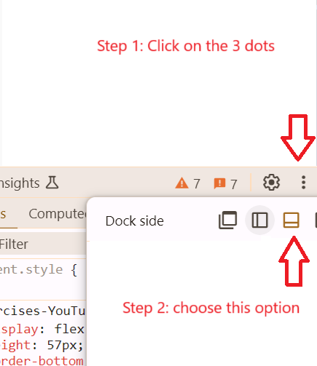
Now when you resize your webpage , the page width and height will show on thw top left corner

